**ERA and DG NEAR sign the second contract for support to IPA II beneficiaries for 2020-2022**

**13Dec**2019

At the beginning of December 2019, ERA and the European Commission’s Directorate General DG NEAR signed a three years contract "Continuation of support to the IPA II beneficiaries by the European Union Agency for Railways (ERA) 2020 – 2022".

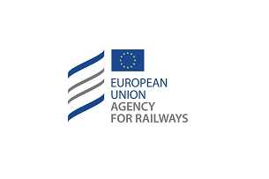

The contract will allow the Agency to continue its efforts supporting the beneficiaries of the Western Balkans and Turkey under the European Union’s instrument for pre-accession assistance (IPA).

The IPA-Project is the means by which the EU supports reforms in the 'enlargement countries' with financial and technical help. The IPA funds build up the capacities of the countries throughout the accession process, resulting in progressive, positive developments in the region.

Current beneficiaries are: Albania, Bosnia and Herzegovina, Kosovo (this designation is without prejudice to positions on status, and is in line with UNSCR 1244 and the ICJ opinion on the Kosovo declaration of independence), Montenegro, North Macedonia, Serbia and Turkey.

In the past, the EU Agency for Railways has already successfully implemented several IPA-Projects and hopes to continue its trustful cooperation with the beneficiaries.

For more information contact us by [email](mailto:ipa@era.europa.eu).